|  |
| --- |
| Arkansas Tech University - CIS Department |
| Website Outline |
| Islam Ebeid |

# Purpose

This web site is designed to offer a variety of information for the computer and information science department and to be a complete reference for target audience: Current Students, Future Students, Parents, Potential Employees, and Alumni and the ABET.

Specifically it provides:

* information on Programs offered by the department
* Course catalogs
* Information about the faculty and staff
* Latest news and events regarding the department
* Scholarships offered
* Student interaction : form submission , class schedules

# Site Organization



# Description

* **Home Page :** It is the welcome page for the website where it can contain images for the department , the link navigation bar and the news section
* **About Us :**

This page is intended to get the visitor know the department in a non academic way through reading the dean’s word , know the staff running the department and see some photos to be able to visualize the place.

* + - **Mission :** Mission is usually the purpose of the staff and what quality and commitment will they offer and a word by the dean
    - **Advisory Board :** Contains a list of advisors and their curriculum
    - **Faculty and Staff :**  A directory of all faculty professors and staff employees including their offices and hours and contacts
    - **Offices :**  Provides information about the building and the room numbers and places and a top view map
    - **Facts and Stats :** Some facts and statistics about the department and students
    - **Photos :**  a photo album taken at many places in the building
* **Academics :** Probably a word about the quality of academics and then links to the following
  + - **Degrees and Programs :**  A list of offered degrees and programs linking to the degree curriculum
    - **Departments :** A list of internal departments like “Computer Science”, “Information Systems” or “Information Technology”
    - **Course Catalogs :** A list of all offered courses and their description and contents
* **Current Students :** Information for current students enrolled in the department
  + - **Schedules :** Offered course schedules and information
    - **Forms :** Contains links to official forms like : “Permit to Register” or “Drop Classes”
    - **Activities :** Links to different activities that the student can enroll in like : “Computer Club”
* **News and Events :** 
  + - **Latest News :** A feed with latest department news
    - **Latest Events :**  A Calendar with the latest events happening in the department
* **Career :** Search and Apply for a job in the department
* **FAQs :** A bank of all frequently asked questions with their answers

# Screen Shots

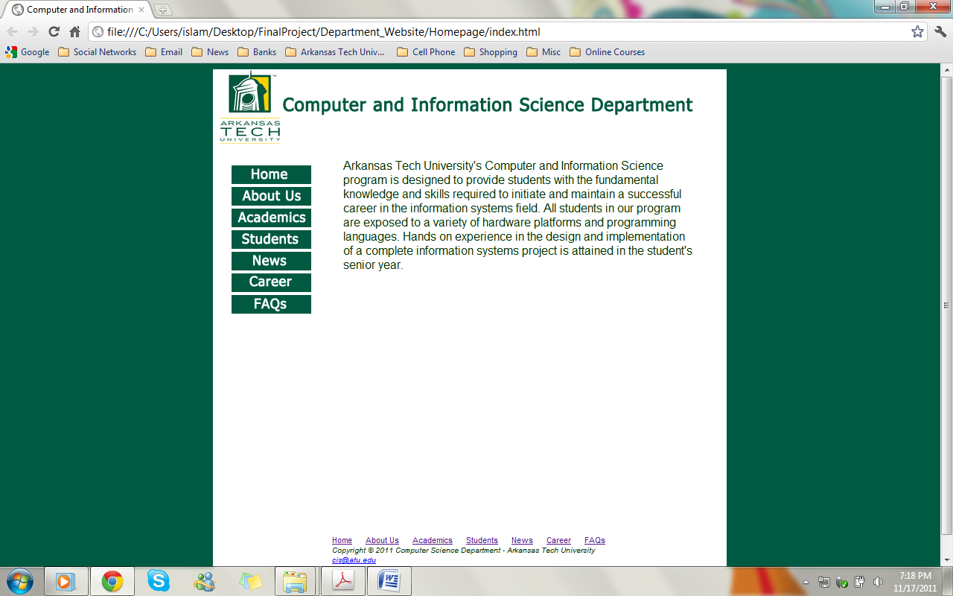

Home Page

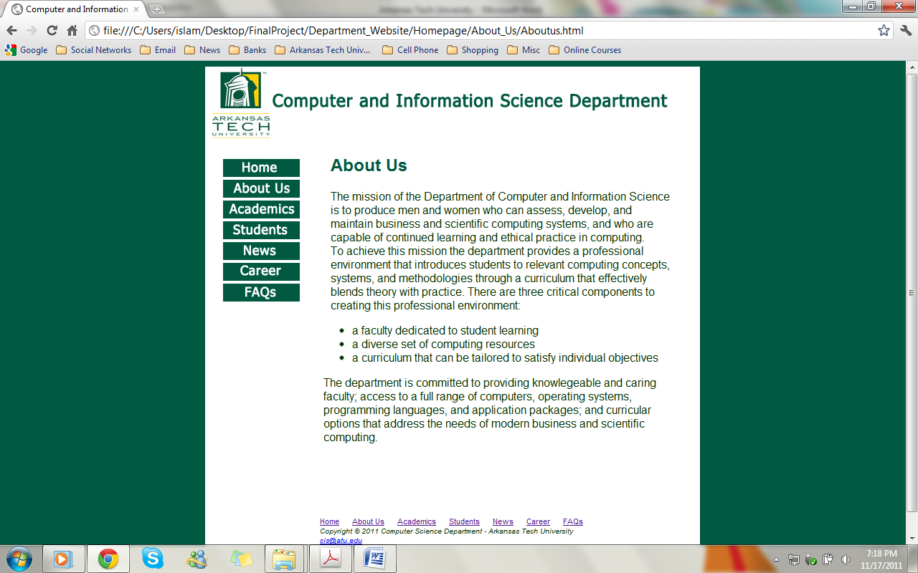

About Us Page